|  |  |
| --- | --- |
| cid:image001.png@01D9E625.7E869D30 | |
| JOHN CORNYN | CONTACT: Natalie Yezbick, (202) 224-0704 |
| United States Senator – Texas | Mary Kate Korinek, (512) 461-7036 |
| For Immediate Release | Tuesday, October 24, 2023 |

**PHOTO: Cornyn Meets with Texas Tech Leadership**

**WASHINGTON** – U.S. Senator John Cornyn (R-TX) met today with the Texas Tech University (TTU) System Chancellor Tedd Mitchell, TTU President Lawrence Schovanec, and Midwestern State University President Stacia Haynie to discuss semiconductor education research and other priorities for the University System. See photo attached and below.

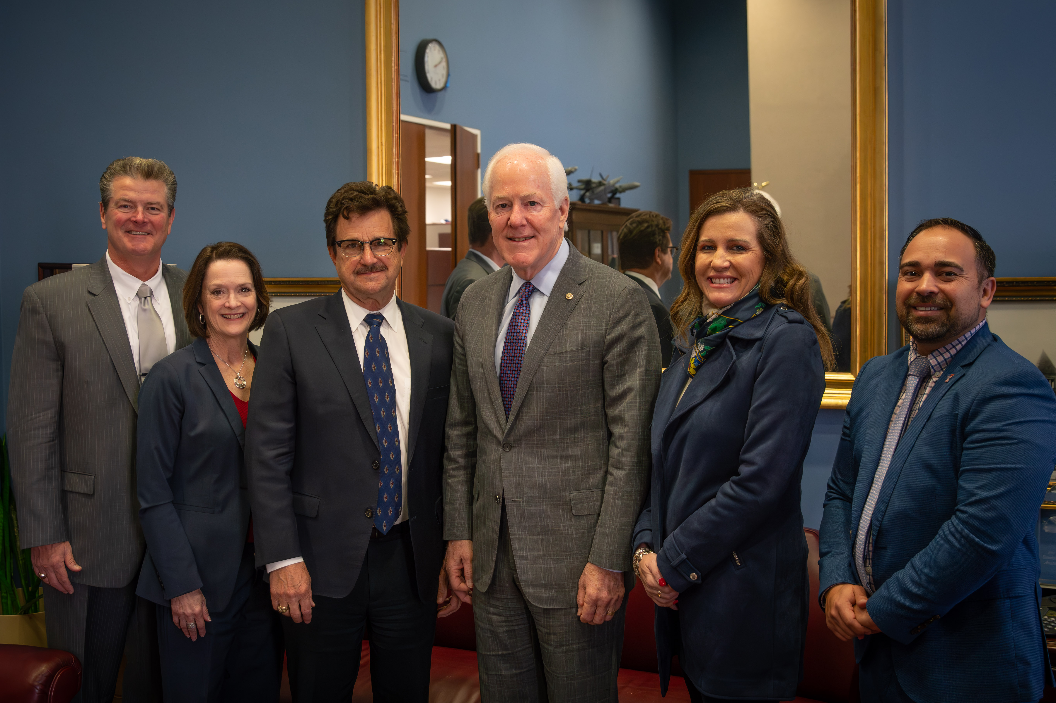

*This image is in the public domain, but those wishing to do so may credit the Office of U.S. Senator John Cornyn.*

*Senator John Cornyn, a Republican from Texas, is a member of the Senate Finance, Intelligence, and Judiciary Committees.*

###